

2024

ST10440580

8/12/2024

WEDE5020_POE_Part 1(POE)



Table of Contents

Ideation and Sourcing Assests 2

Website Assets 4

WEBSITE PAGES AND CONTENTS 6

Reference List 9

PART 2 9

Improvements to Part 1 website 9

Improvements to Part 1 process document 10

WEB POE Part 1

# Ideation and Sourcing Assests

Website Choice

**AIDS Foundation of South Africa(AFSA) NGO**

**Description of the organization:**

Established in 1988,the AIDS Foundation of South Africa(AFSA) was the first registered AIDS Non-Governmental Organisation in South Africa. Focusing on Combination Prevention and Treatment, Child Protection and Wellbeing, Food Security and Income Generation, AFSA aims to deliver quality services to communities most in need. Policy and Practice through the promotion of equality, education and access to basic services is a cornerstone of these efforts.

 AFSA recognises that the HIV epidemic is rooted in social and relational phenomena conditioned by environmental, cultural, political and socio-economic drivers. Given the complex reality that HIV affects communities and subgroups differently, AFSA uses strategies that address the social and structural drivers of HIV/AIDS and integrates interventions into a broader sexual and reproductive health framework. AFSA focuses on geographies and populations with elevated risk, thereby effectively and efficiently maximizing prevention impact.

**Why I chose this particular organization?**

This organization focuses on Combination Prevention and Treatment, Child Protection and Wellbeing, Food Security and Income Generation, AFSA aims to deliver quality services to communities most in need. Policy and Practice through the promotion of equality, education and access to basic services is a cornerstone of these efforts.

 AFSA recognises that the HIV epidemic is rooted in social and relational phenomena conditioned by environmental, cultural, political and socio-economic drivers. Given the complex reality that HIV affects communities and subgroups differently, AFSA uses strategies that address the social and structural drivers of HIV/AIDS and integrates interventions into a broader sexual and reproductive health framework. AFSA focuses on geographies and populations with elevated risk, thereby effectively and efficiently maximizing prevention impact. Doing this may be hard to maintain which is why it will be linked to the in-app purchases of the mobile game CALL OF DUTY which will fund the organization.

**How my website will be structured ?**

AFSAxCOD will be the name of the website.It is designed to connect the world of online gaming with real-life social impact, specifically targeting support for AIDS Foundation South Africa (AFSA). The platform integrates charitable activities into the gameplay of Call of Duty, leveraging the gaming community’s engagement to generate funds and awareness for AFSA’s mission.

**Charity Leagues**: Players participate in special sub-leagues with unique game modifications. To join these leagues, they contribute financially to AFSA. In-game purchases, such as virtual items and supporter packs, also channel funds directly to the foundation.

**Community Challenges**: AFSAxCOD features AFSA-themed challenges, including boss kills, speedruns, and crafting achievements. Successful completion of these challenges results in AFSAxCOD making financial donations to AFSA.

**Education Hub**: The platform provides resources such as tutorials, articles, and videos focused on HIV/AIDS awareness, other sexually transmitted infections, and combating stigma. This educational content aims to foster empathy and understanding within the gaming community.

**In-Game Merchandise**: AFSAxCOD collaborates with Grinding Gear Games to offer limited-edition MTX items. Proceeds from these items are directed to AFSA, further supporting their programs.

**Real-Life Impact Stories**: The platform highlights real stories of individuals whose lives have been positively affected by AFSA’s work, demonstrating the tangible outcomes of the community’s efforts.Why AFSAxCOD? By merging gaming with social activism, AFSAxCOD taps into the potential of the youth in gaming communities to drive real-world change. The platform ensures that each contribution is impactful, reinforcing the connection between virtual battles and real-life victories against HIV/AIDS.

**Implementation**: AFSAxCOD’s process includes conceptual development, collaboration with AFSA, website creation, launch, and ongoing engagement through updates and community outreach.

**Donation option:** The website will allow users to link their call of duty accounts to the website.

# Website Assets

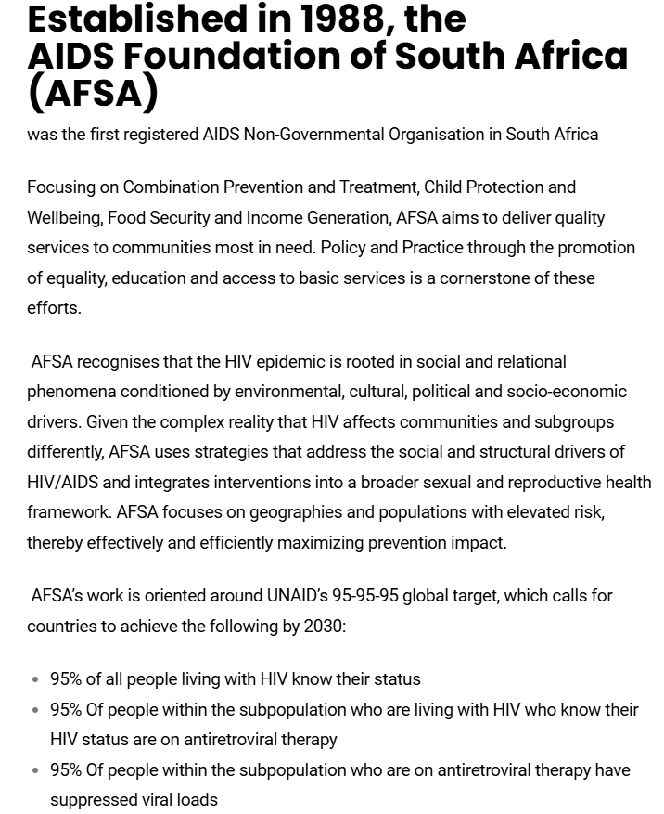

(Employee, 2024)

Navigation to use my website

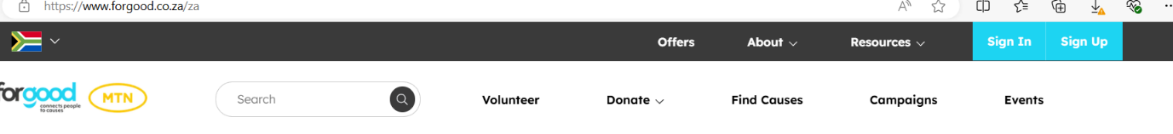

Images to use for my website

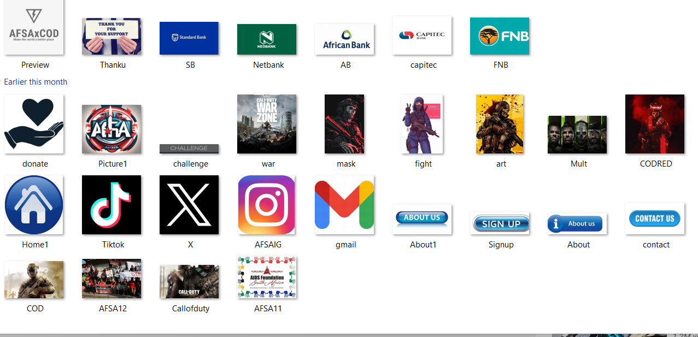

# WEBSITE PAGES AND CONTENTS

Webpages I intend on creating:

* Homepage
* About us
* Contact Us
* Signup
* Donate

**1.Homepage-AFSA**

* Logo of website
* Pictures
* Information about the website
* More information about the challenges
* How to donate
* Link that leads to all the other webpages
* Copyright

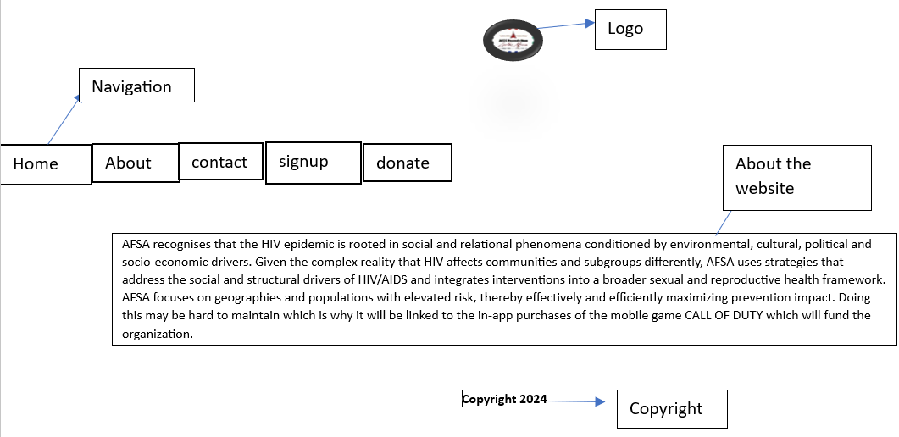

**2.About Us**

* Information about organisation we partnered with.
* Pictures of their work
* Link that leads to all the other webpages
* Logo of website
* Copyright

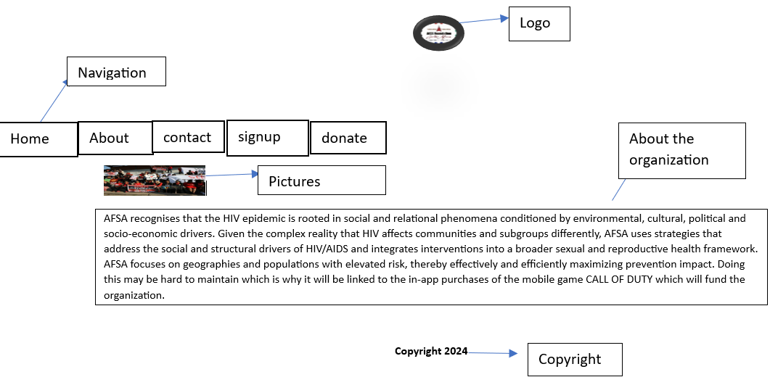

**3.Contact Us**

* Information on where to find us.
* Pictures of the different platforms.
* Link that leads to all the other webpages
* Logo of Website
* Copyright

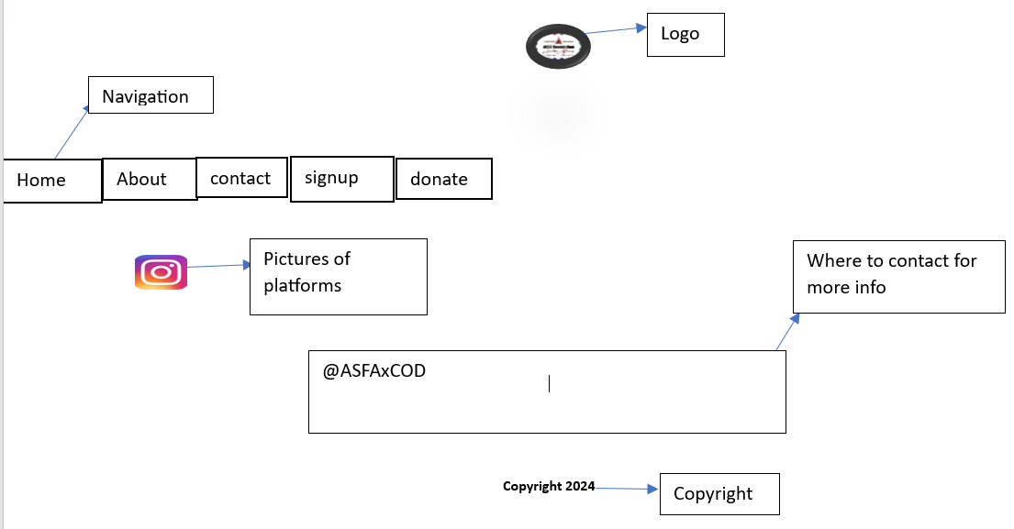

**4.Sign up**

* Tabs that allow users to insert their name,lastname and more
* Link that leads to all the other webpages
* Logo of website
* Copyright

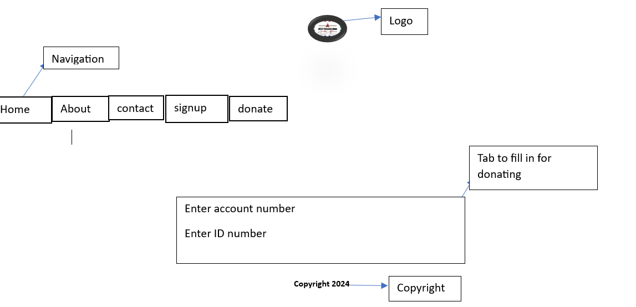

**5.Donate**

* Tab that allow user to insert the amount they would like to donate.
* Link that leads to all the other webpages
* Logo of Website
* Copyright

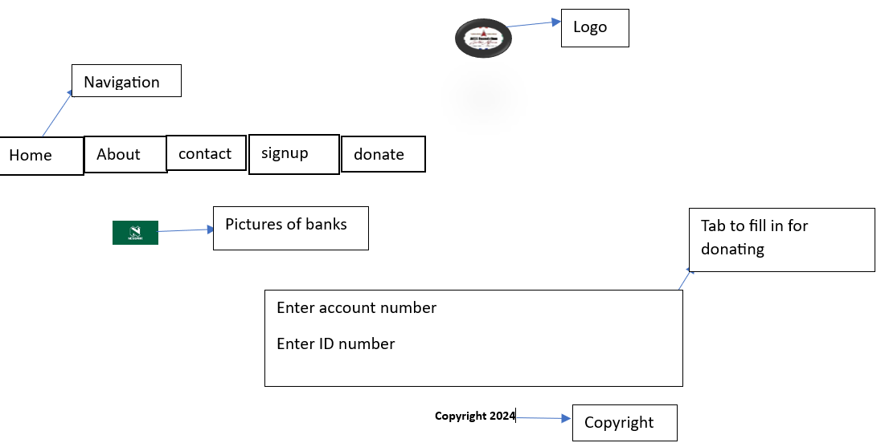

# Reference List

Employee, A. F. S. A., 2024. *AIDS FOUNDATION SOUTH AFRICA.* [Online]   
Available at: https://th.bing.com/th/id/OIP.NDpEjYeQWCYJuL8lpQzYngHaE8?rs=1&pid=ImgDetMain  
[Accessed 12 August 2024].

Wall, P., 2024. *PICS WALL.* [Online]   
Available at: https://www.picswalls.com/pic/call-of-duty-wallpapers/  
[Accessed 12 August 2024].

# PART 2

## Improvements to Part 1 website

* The first thing I improved was the appearance of the pictures in my homepage and contact page. I did this by adding a card tag so that my pages can be displayed as cards instead of pictures that were scattered all over the webpage. This made the webpage more professional and easier to read.
* The second thing I improved was my navigation bar. I did this by removing the counterfeit pictures that acted as buttons and replaced them with the navbar tags as shown on line 16-25(Code was copied onto all the webpages). This made the website more efficient and improved the readability.
* I also improved my About us webpage. This page wasn’t very reader friendly as the picture was on top of the information. I improved this by simply adding a new class to my style sheet and edited the picture to be right aligned to the text line (138 of my style sheet).
* I also improved the logo placement by displaying the logo with the navigation bar in the same line, all this was done in my stylesheet.
* I also changed the background of all my webpages by adjusting the rgba of it. I did this because the old background colour wasn’t professional and it made users lose interest in learning more about the website.
* I also removed a few pictures in my homepage in order to give my website a neat and professional look.
* I also changed the pathway of the pictures to the actual name of the picture, I did this because in my part 1 the images weren’t appearing. I did this by simply just linking the image file to its actual name.

## Improvements to Part 1 process document

**1.Homepage-AFSA**

* Logo of website
* Pictures
* Information about the website
* More information about the challenges
* How to donate

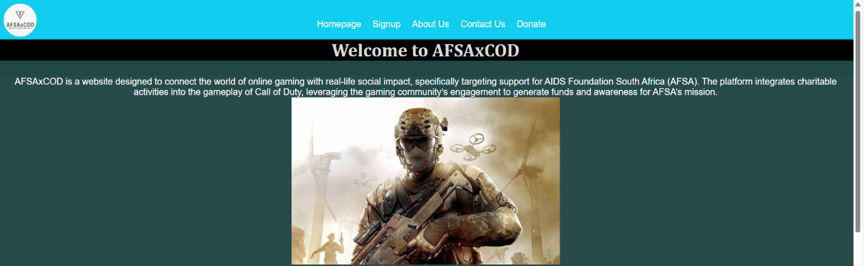

**2.About Us**

* Information about organisation we partnered with.
* Pictures of their work
* Link that leads to all the other webpages
* Logo of website
* Videos(new)
* Copyright

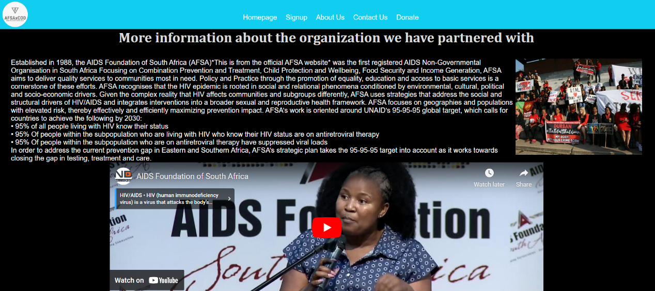

**3.Contact Us**

* Information on where to find us.
* Pictures of the different platforms.
* Link that leads to all the other webpages
* Logo of Website
* Copyright

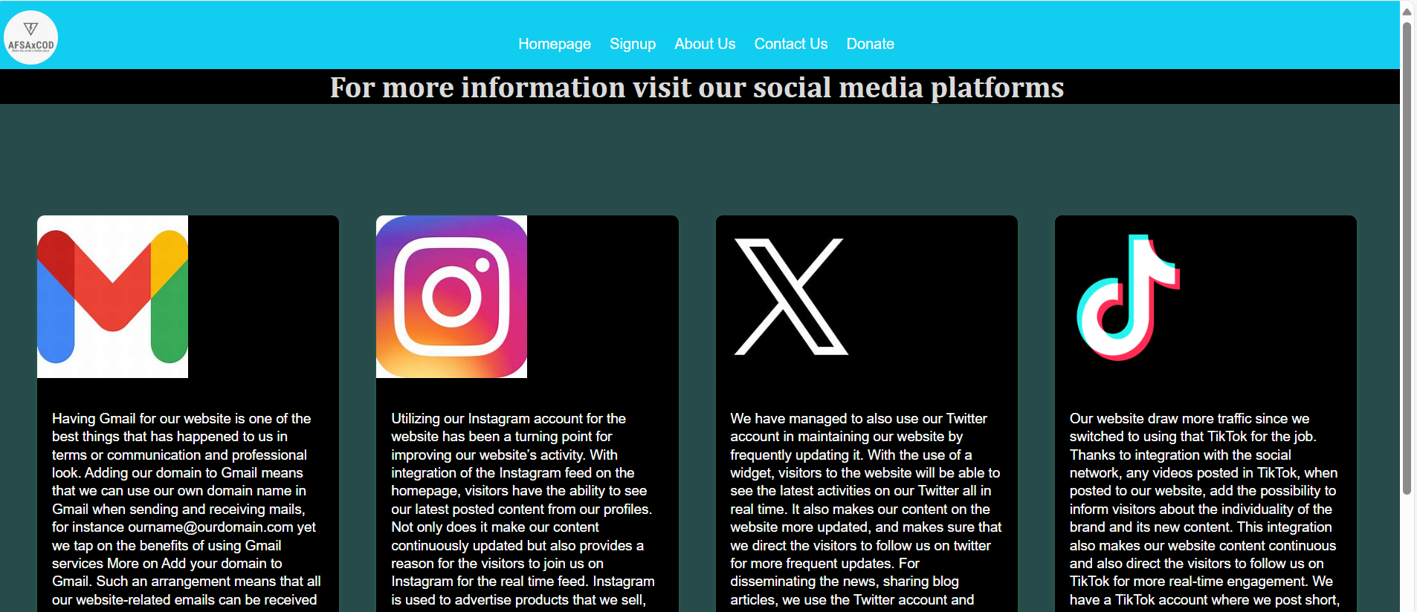

**4.Sign up**

* Tabs that allow users to insert their name,lastname and more
* Link that leads to all the other webpages
* Logo of website
* Copyright

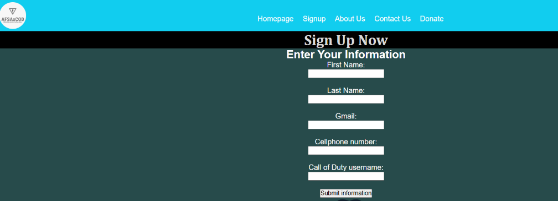

**5.Donate**

* Tab that allow user to insert the amount they would like to donate.
* Link that leads to all the other webpages
* Logo of Website
* Copyright

